# Economies and Diseconomies of Scale – Part 1 Goliath

There is a curious unasked question that serves as a back drop to much of the media’s reporting on the economy. If big business is so powerful, why is it that most people in the private sector of the United States work in small and medium businesses? Surely both the power that these businesses yield (lobbying, political, and resources) and the economy of scale they enjoy would allow them to outperform and outlast their competitors in the smaller firms. Asked differently, why isn’t the world dominated by huge multinational corporations?

This idea of the dominance of big business is certainly common fare in the daily fiction that passes in movies and TV. Many tales come out every year featuring the evil, predatory practices and near omnipotent power of big business and yet the small and medium rebellion continues unabated every year.

Now to be clear, I am neither suggesting that big business is benevolent nor that it exercises its power gently. Businesses, large or small, have a right and perhaps an obligation to aggressively protect their market share and to continue to grow. In addition, crony capitalism and political favoritism tends to give the larger firms political concessions that the smaller firms lack. What I am suggesting, or at least exploring, is the notion that smaller can be better and that we tend to remember economies of scale and forget about diseconomies of scale.

To better understand the staying power of small and medium business, consider some elementary statistics.

Small businesses make the bulk of the US economy both in terms of the number of firms and in terms of the number of employees. According to statistics provided by [Census Bureau](http://www.census.gov/econ/smallbus.html), 61% of the firms in the country are sized between 1-4 employees and 99.6% of the firms have fewer than 500 employees. Nearly 50% of the employees in the economy work in this segment.

The wages these employees make, in aggregate, are comparable to the wages earned by their big business counterparts. Although a more detailed analysis by labor segment (e.g. secretary to secretary) in addition to size of firm is needed to make clear conclusions, there doesn’t seem to be obvious evidence that being in a big business significantly increases wages.

The table below, adapted from 2007 data from the Census Bureau, shows the details

|  |  |  |  |  |  |
| --- | --- | --- | --- | --- | --- |
| Size of Firm | Number of Firms | Paid Employees | Dollars to Labor | Average # Employees | Average Wage |
| 1-4 | 3,617,764 | 6,086,291 | 232,062,907 | 1.7 | 38.1 |
| 5-9 | 1,044,065 | 6,878,051 | 222,504,912 | 6.6 | 32.3 |
| 10-19 | 633,141 | 8,497,391 | 293,534,352 | 13.4 | 34.5 |
| 20-99 | 526,307 | 20,684,691 | 774,589,335 | 39.3 | 37.4 |
| 100-499 | 90,386 | 17,547,567 | 706,476,693 | 194.1 | 40.3 |
| 500-749 | 6,060 | 3,681,760 | 156,491,764 | 607.6 | 42.5 |
| 750-999 | 3,038 | 2,617,087 | 114,635,897 | 861.5 | 43.8 |
| 1000-1499 | 3,044 | 3,720,654 | 167,658,791 | 1222.3 | 45.1 |
| 1500-1999 | 1,533 | 2,653,392 | 121,800,728 | 1730.8 | 45.9 |
| 2000-2499 | 904 | 2,011,244 | 94,406,916 | 2224.8 | 46.9 |
| 2500-4999 | 1,934 | 6,726,611 | 329,188,349 | 3478.1 | 48.9 |
| 5000-9999 | 975 | 6,773,466 | 337,598,036 | 6947.1 | 49.8 |
| >10000 | 981 | 33,025,346 | 1,579,560,498 | 33665.0 | 47.8 |

Now let’s talk a little about all the advantages enjoyed by big business (say more than 1000 employees) that are either available to a lesser degree for smaller firms or unavailable entirely. This discussion will focus only on the legitimate advantages afforded to these firms from economy of scale effects and will ignore additional, unfair, advantages due to lobbying and crony capitalism.

As a reminder, an economy of scale is the term that is used to describe any effect that allows the cost per unit of production to lower as the number of units produced grows. Large firms generally have three areas that provide them with economy of scale advantages.

The first is in the form of non-reoccurring costs or what is sometimes known as sunk costs. This category covers all the initial investment in the production capital, such as factories and specialized machinery. A milling machine comes with a fixed price tag whether it is used to produce 1 unit of goods or 100. In the latter case, the initial outlay for the machine can be recouped over a large customer base and so allows the cost per unit to be reduced. Similar advantages occur for advertising and marketing, where the price passed onto consumers is smaller per good the larger the number of consumers, and for shipping, where it is cheaper to have truck that ships 200 goods than to have two smaller trucks that ship 100 goods each. Finally, a large firm typically has greater financial resources and can bear the risk associated with research and development of new goods and services more easily than smaller ones.

The second advantage is that larger firms comes in the form of the workforce. Employees at larger firms can more easily specialize, leading to production. The prototypical example of this is given in Adam Smiths ‘The Wealth of Nations’. Smith examined how straight pins were made and identified 18 distinct tasks. A single worked performing each of these 18 tasks might be able to produce 20 pins in a day. By dividing up the tasks amongst several workers so that one worked performed only 1 or 2 of them, Smith estimated that a group of 10 workers could produce 48,000 pieces in the same time. Division of labor and specialization enabled each worked to increase his output by over a factor of 200. Large-firm employees also enjoy a larger community from which to learn and environment filled with greater intellectual capital and corporate knowledge.

The third advantage is the leverage that big businesses have in procuring goods and services. They can bulk buy from suppliers and vendors and receive a discount that is out of reach for the smaller firms. They can also command better terms and concessions on loans and related financial instruments that can be used to increase their production.

So having enumerated all these great advantages, how can small firms ever compete? And yet, they not only compete they also dethrone the giants of yesterday. Not so long ago, IBM was the unassailable provider of computers and business machines. Within two or three decades, Microsoft had supplanted IBM. As time progresses there is mounting evidence of Microsoft losing ground to both Apple and Google. Other examples from every enterprise and industry can be found where yesterday’s giants are today’s has-beens; simply look at Abercrombie & Fitch, or Nokia, or Borders, or… well you get the picture.

In next week’s column, I’ll discuss how the David’s of the economy can defeat the Goliaths. Stay tuned.

# Economies and Diseconomies of Scale – Part 2 David

The week’s exploration centers on how a small organization or firm can successfully compete with a larger corporation. Three substantial advantages associated with economies of scale naturally fall to a large and established firm. These are ability to amortize sunk costs over a large customer base, the possession of a larger and more specialized workforce, and leverage in buying goods and services. With all these advantages, how can smaller business ever hope to survive let alone compete? And, as a corollary question, how come large firms don’t grow unboundedly?

The simple answer is that firms also suffer from a host of disadvantages, called diseconomies of scale, that grow larger as the size of the firm goes. Initially, these disadvantages are not active in smaller firms. But at some point, above a critical size, they turn on and begin to offset the economy of scale advantages.

There are two primary areas where diseconomies of scale present themselves: delegation of authority, span of control, and the principal agent problem; and poor communication, coordination, and standardization.

Let’s start with the first broad category which covers problems associated with delegation of authority, span of control, and the principal agent problem. Collectively, these problems describe the down side of the principle behind [comparative advantage](http://commoncents.blogwyrm.com/?p=27). No matter how talented and dedicated the original founders and staff of a firm are, they are limited in the amount they can do based simply on the number of hours in a day. For the firm to grow, additional staff needs to be hired to not only perform the basic functions (manufacturing, delivery of services, etc.) but also manage the growth.

In this process, a vast amount of control and authority has to be delegated to new staff and this is always accompanied by growing pains. Friction between the old guard and the young turks is natural even under the best of circumstances. When rapid growth occurs in a firm it is usually due to a highly motivated core group (e.g. the owners of the company). These individuals obviously have strong notions about what works and what doesn’t. In addition, they want go-getters just like themselves and they tend to hire people who are just as opinionated and strong willed as they are themselves. I’ve experienced the tremendous clash that happens next. The new blood yells about micromanagement and rigid and inflexible approaches of the existing management, who can’t delegate and reduce their span of control. The original staff can’t understand why there is a sudden rush to change the culture that has been so successful. Harsh words are exchanged, people quit or get fired and, meanwhile, the business of the firm is left fallow.

As bad as this is, an even worse circumstance occurs when the new blood has designs on the existing corporate structure for their own purposes. They may see a niche area left undeveloped or may want to move the company in a direction more suited to their personal liking. In some cases, they may even be dishonorable people looking to exploit the existing cash cow with some scheme or another. This is the [principal agent problem](http://en.wikipedia.org/wiki/Principal%E2%80%93agent_problem). Central to this situation is a difference in the amount of knowledge the two parties possess. The principal is the term used to describe the existing management/ownership. In hiring the new staff, which are called the agents, the principal must trust the agent and delegate some ability for the agent to make decisions on behalf of the principal. Both the principal and the agent have their own self-interest, but while the principal has the advantage in authority, the agent has the advantage in terms of information. In all cases, the agent is required to report back to the principal (even if the reporting is a token report) and all agents filter the information at their disposal before sending it on to the principal. The larger the firm the more likely it is that at least one of its agents is using this asymmetry for this own ends at the expense of the firm.

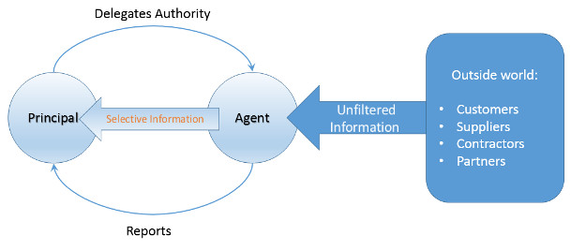

The second broad category of diseconomies of scale includes problems with communication, coordination, and standardization. Overall, I tend to refer to these problems collectively as the Dinosaur Problem. The organization in question has the same issues that the Jurassic behemoths had. Small organizations can comfortably handle peer-to-peer interactions since the number of people involved is relatively small. Once the size exceeds a critical threshold it is more efficient for interactions to happen through a central location, a manager who facilitates the activities of a whole. As the numbers continue to grow more managers come on board and the interaction between them may be handle by peer-to-peer even though the employee interactions are not. At some point, however, the number of managers becomes too large and a new layer of management is conceived and implemented. This layering continues until some point where the right-hand no longer knows what the left hand is doing.

Along the way, such a firm begins to exhibit all the tell-tale signs of being too large. The implementation of a one-size-fits all strategy to avoid liabilities. Having meetings about how to have meetings or for the sake of having meetings. And an emphasis on fairness rather than performance.

<iframe width="560" height="315" src="https://www.youtube.com/embed/kKceJUcZ67Y" frameborder="0" allowfullscreen></iframe>

I’ve lived through all these types of insanities. One of the firms where I worked had a supply requisition form on which one could order refills for X-Acto knives (this was for the actual paper-and-glue version of cutting and pasting) but not the knives themselves. I was issued a corporate American Express card with the very explicit admonition to only use it for business travel and not for personal use. A scant 6 years later I received a letter from legal saying that they were going to revoke my American Express card because I had failed to live up to the expected use of the card. All told, I had never wanted the card in the first place and I was sent on only two business trips in those 6 years. I’ve been required to attend a meeting about how to have meetings.

All of this factors contribute to limiting the practical size of a firm. In the economic lingo, [the economies and diseconomies of scale](http://en.wikipedia.org/wiki/Diseconomies_of_scale) are best summarized on an average cost diagram.

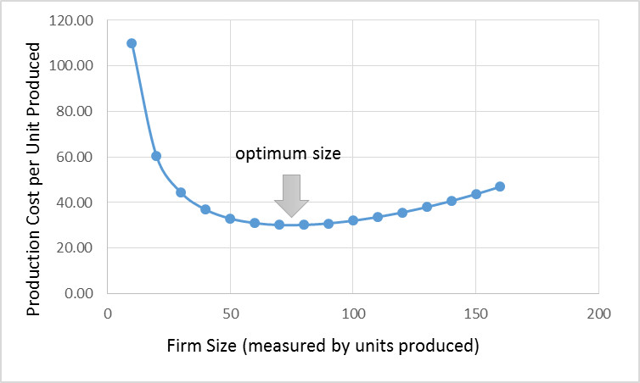

On the x-axis is the number of units of some good or service produced by the firm, which is taken as a measure of the firm’s size. On the y-axis is the cost to produce a unit of the good. The optimum occurs at the place where the benefits from the economies of scale balance the diseconomies. It is important to note that as business factors change, what once contributed to a cost savings can turn around and cause an increase in cost.

So it isn’t remarkable that the small business Davids can take down the big business Goliaths. It also isn’t remarkable that today’s Goliaths were yesterday’s Davids and tomorrow’s has-beens. That is the nature of the creative destruction of the free market economy. It also isn’t remarkable that economies of scale one day can become diseconomies of scale on another as society evolves. What is remarkable is how many people refuse to accept this dynamic.